CO2 EXPERIMENT 13

Title: CNN-Based Handwritten Digit Classification using MNIST

Objectives:

To implement a Convolutional Neural Network (CNN) for handwritten digit classification using the MNIST dataset and evaluate its performance using accuracy, confusion matrix, training and validation graphs, and sample predictions.

Procedure:

- Import the required Python libraries: TensorFlow, NumPy, Matplotlib, and scikit-learn.
- Load the MNIST handwritten digit dataset containing digits from 0 to 9.
- Preprocess the images by normalizing pixel values between 0 and 1.
- Divide the dataset into training, validation, and testing sets.
- Build a CNN model using convolution, max-pooling, flatten, dense, and dropout layers.
- Compile the model using the Adam optimizer and sparse categorical cross-entropy loss.
- Train the model for five epochs and record training and validation accuracy and loss.
- Test the trained model using the test dataset.
- Plot the training and validation accuracy and loss graphs.
- Generate a confusion matrix and display sample digit predictions.
- Calculate test accuracy, inference latency, and model parameter count.

Program code

# Install required packages:
# pip install tensorflow matplotlib scikit-learn numpy

import time
import numpy as np
import matplotlib.pyplot as plt
import tensorflow as tf
from tensorflow.keras import layers, models
from sklearn.metrics import confusion_matrix, ConfusionMatrixDisplay, classification_report

# 1. Load MNIST dataset
(x_train_full, y_train_full), (x_test, y_test) = tf.keras.datasets.mnist.load_data()

# 2. Normalize images and add channel dimension
x_train_full = x_train_full.astype("float32") / 255.0
x_test = x_test.astype("float32") / 255.0
x_train_full = x_train_full[..., np.newaxis] # (N, 28, 28, 1)
x_test = x_test[..., np.newaxis]

# 3. Split training data into training and validation sets
x_train, x_val = x_train_full[5000:], x_train_full[:5000]
y_train, y_val = y_train_full[5000:], y_train_full[:5000]

print("Training images:", x_train.shape[0])
print("Validation images:", x_val.shape[0])
print("Testing images:", x_test.shape[0])

# 4. Build CNN model
model = models.Sequential([
layers.Input(shape=(28, 28, 1)),
layers.Conv2D(32, (3, 3), activation="relu"),
layers.MaxPooling2D((2, 2)),
layers.Conv2D(64, (3, 3), activation="relu"),
layers.MaxPooling2D((2, 2)),
layers.Flatten(),
layers.Dense(64, activation="relu"),
layers.Dropout(0.3),
layers.Dense(10, activation="softmax")
])

model.compile(
optimizer="adam",
loss="sparse_categorical_crossentropy",
metrics=["accuracy"]
)

model.summary()

# 5. Train the model and record training/validation metrics
history = model.fit(
x_train, y_train,
epochs=5,
batch_size=128,
validation_data=(x_val, y_val),
verbose=1
)

# 6. Test model
test_loss, test_accuracy = model.evaluate(x_test, y_test, verbose=0)
print(f"\nTest loss: {test_loss:.4f}")
print(f"Test accuracy: {test_accuracy * 100:.2f}%")

# 7. Plot training and validation accuracy
epochs = range(1, len(history.history["accuracy"]) + 1)
plt.figure(figsize=(8, 5))
plt.plot(epochs, history.history["accuracy"], marker="o", label="Training Accuracy")
plt.plot(epochs, history.history["val_accuracy"], marker="o", label="Validation Accuracy")
plt.title("Training and Validation Accuracy")
plt.xlabel("Epoch")
plt.ylabel("Accuracy")
plt.grid(True)
plt.legend()
plt.tight_layout()
plt.savefig("accuracy_graph.png", dpi=150)
plt.show()

# 8. Plot training and validation loss
plt.figure(figsize=(8, 5))
plt.plot(epochs, history.history["loss"], marker="o", label="Training Loss")
plt.plot(epochs, history.history["val_loss"], marker="o", label="Validation Loss")
plt.title("Training and Validation Loss")
plt.xlabel("Epoch")
plt.ylabel("Loss")
plt.grid(True)
plt.legend()
plt.tight_layout()
plt.savefig("loss_graph.png", dpi=150)
plt.show()

# 9. Predict test images
probabilities = model.predict(x_test, verbose=0)
y_pred = np.argmax(probabilities, axis=1)

# 10. Confusion matrix
cm = confusion_matrix(y_test, y_pred, labels=np.arange(10))
display = ConfusionMatrixDisplay(confusion_matrix=cm, display_labels=np.arange(10))
fig, ax = plt.subplots(figsize=(9, 9))
display.plot(ax=ax, cmap="Blues", values_format="d", colorbar=False)
plt.title("CNN Confusion Matrix - MNIST Test Set")
plt.tight_layout()
plt.savefig("confusion_matrix.png", dpi=150)
plt.show()

# 11. Classification report
print("\nClassification Report:")
print(classification_report(y_test, y_pred, digits=4))

# 12. Show sample predictions
num_samples = 15
plt.figure(figsize=(12, 7))
for i in range(num_samples):
plt.subplot(3, 5, i + 1)
plt.imshow(x_test[i].squeeze(), cmap="gray")
predicted = y_pred[i]
actual = y_test[i]
color = "green" if predicted == actual else "red"
plt.title(f"Pred: {predicted} | True: {actual}", color=color)
plt.axis("off")
plt.suptitle("Sample Predictions (Green = Correct, Red = Incorrect)")
plt.tight_layout()
plt.savefig("sample_predictions.png", dpi=150)
plt.show()

# 13. Measure inference latency on test samples
sample_batch = x_test[:1000]
start_time = time.perf_counter()
_ = model.predict(sample_batch, verbose=0)
elapsed = time.perf_counter() - start_time
print(f"Average inference time per image (batch of 1000): {elapsed / len(sample_batch) * 1000:.3f} ms")

# 14. Model/resource analysis
total_params = model.count_params()
print(f"Total model parameters: {total_params:,}")
print(f"Model file size (approximate, parameters only, float32): {total_params * 4 / (1024**2):.2f} MB")
model.save("mnist_cnn_model.keras")
print("\nSaved files: accuracy_graph.png, loss_graph.png, confusion_matrix.png, sample_predictions.png")
print("Saved trained model: mnist_cnn_model.keras")

OUTPUT

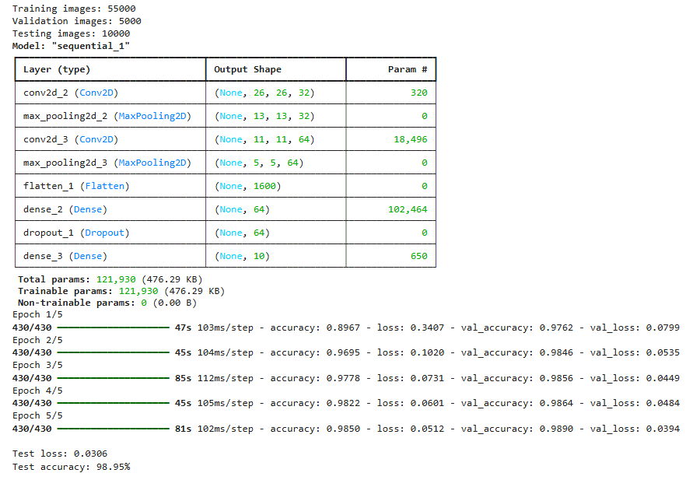

Training and Validation Accuracy

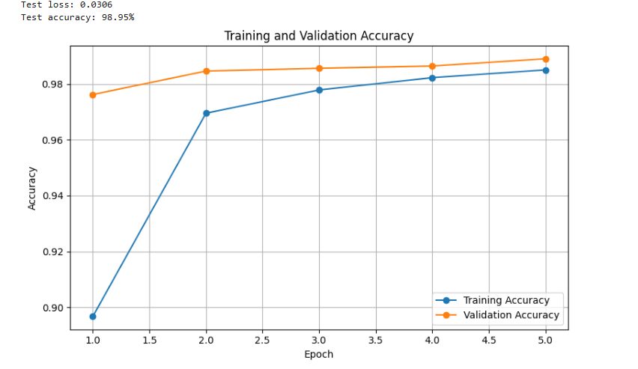

Training ana Validation Loss

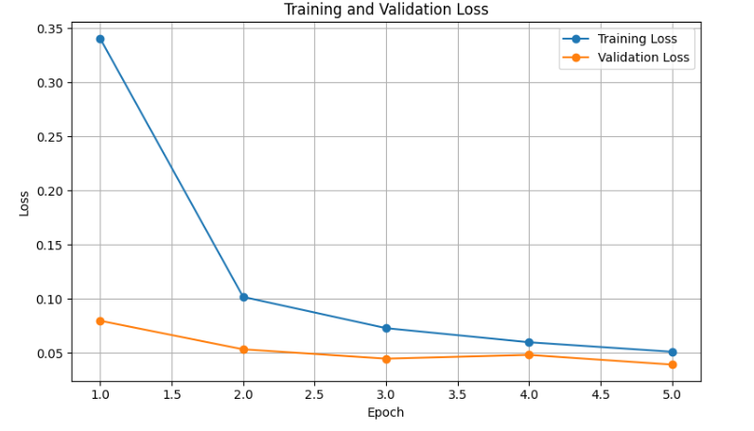

CNN Confusion Matrix

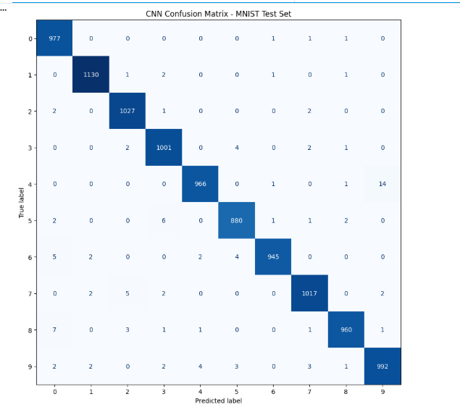

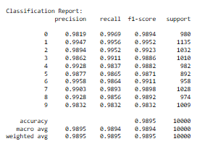

Sample Predictions

